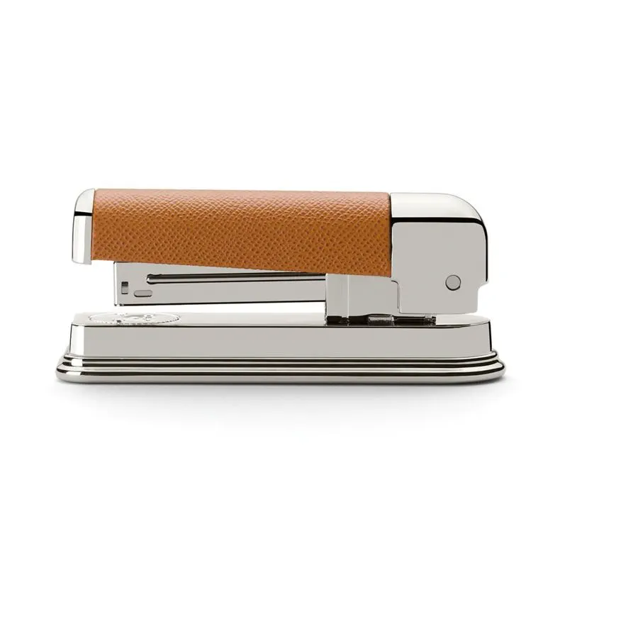

# Stapler Epsom

Cognac

Product details

* High quality stapler, Cognac
* Hand-covered with Italian calfskin
* Highly polished metal parts
* Suitable for open and closed stapling
* Please use staples in standard size 24/6
* Handmade in Germany
* Instructions for product care are included in the manual

Stapler Epsom, Cognac

The Graf von Faber-Castell Collection desk accessories combine clear, restrained design with high-quality materials. Grained calfskin leather and polished metal parts make these accessories both elegant and durable.